**a Real Pic of an Orca in a Flooded City Street**

As if a [Category 4 hurricane making landfall](https://www.cnn.com/2022/09/28/weather/hurricane-ian-florida-path-wednesday" \t "_blank) weren’t terrifying enough, it has become an internet tradition for social media users to share [fabricated pictures](https://www.snopes.com/collections/fake-hurricane-photographs/" \t "_blank) of sharks, alligators, and killer whales prowling the flooded streets of storm-stricken cities.

Thus, as [Hurricane Ian](https://www.snopes.com/tag/hurricane-ian/" \t "_blank) approached mainland Florida in late September 2022, some Twitter and Facebook users encountered photographs like this one in their timelines:

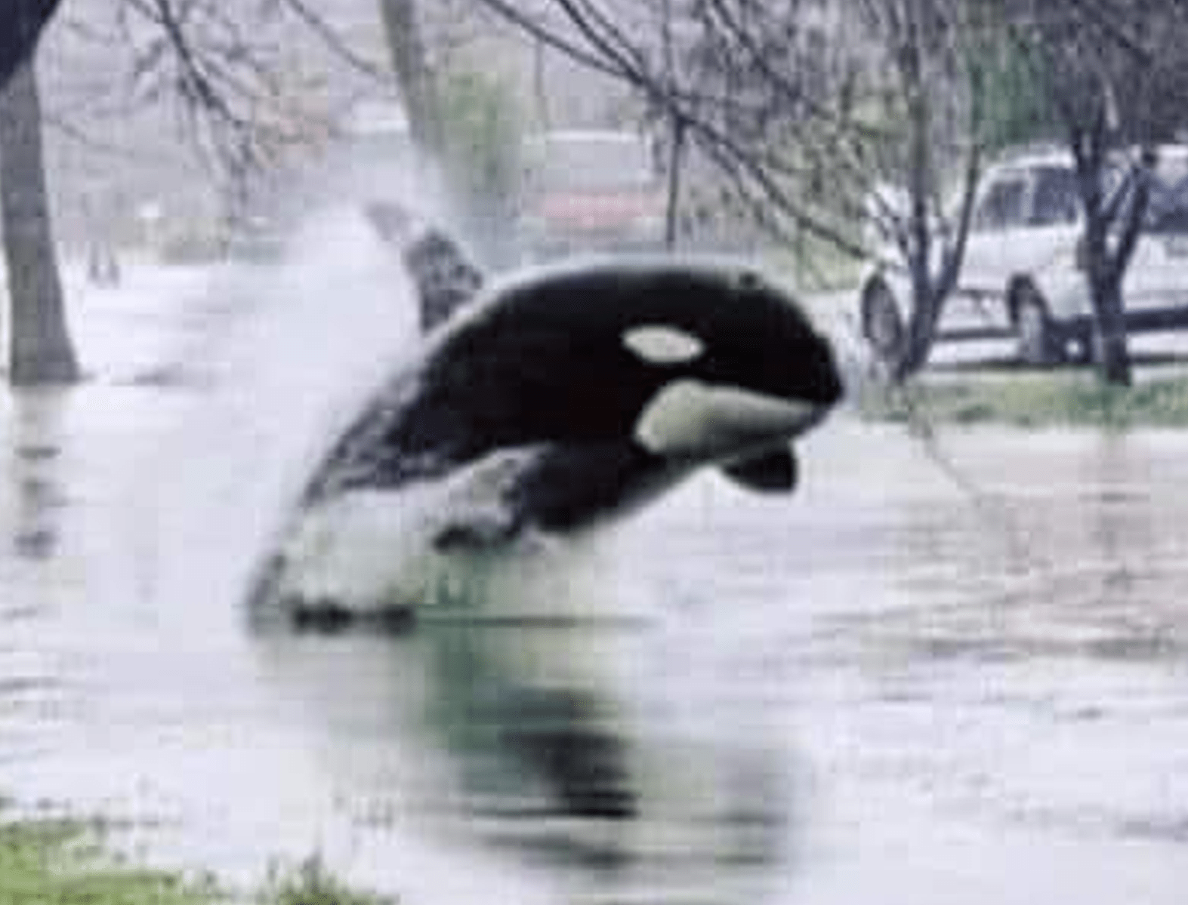

https://www.snopes.com/fact-check/orca-in-flooded-street/